**CHAPTER-1**

**INTRODUCTION**

**INTRODUCTION**

Fake news detection is crucial in today’s digital world, where misinformation can spread rapidly across social media and online platforms. As news consumption increasingly shifts to the internet, distinguishing between credible and false information has become more challenging. Fake news can be deliberately created to mislead, manipulate public opinion, or achieve certain agendas. This project aims to tackle this issue by using machine learning techniques to develop an automated system for detecting fake news. We utilize the TF-IDF (Term Frequency-Inverse Document Frequency) Vectorizer to transform news articles into numerical features that represent the significance of words in the context of the entire dataset, capturing important terms and reducing the impact of common words. The Passive Aggressive Classifier, known for its efficiency in handling large datasets and its ability to adapt quickly to new data, is then used to classify news as real or fake. By training the model on labeled news data, it learns to recognize patterns and anomalies indicative of fake news. This approach not only improves the accuracy of detecting misleading information but also helps in automating the process, making it scalable and applicable to various platforms. The outcome of this project aims to enhance the reliability of information available online, contribute to informed decision-making, and reduce the negative effects of fake news on society.

**Objective of the Project**

The objective of the project is to develop an effective system for detecting fake news using machine learning techniques. By leveraging advanced tools such as the TF-IDF Vectorizer and the Passive Aggressive Classifier, the project aims to accurately classify news articles as real or fake. The goal is to create a reliable model that can analyze and evaluate news content to identify misinformation, thereby improving the credibility of information shared online. This system seeks to enhance the ability to distinguish between genuine and misleading news, helping users make informed decisions and reducing the spread of false information across digital platforms.

**Existing System:**

**1. Time-Consuming Process:**

Identifying fake news manually involves extensive time and effort as users need to cross-check information from various sources, which can be slow and inefficient.

**2. Limited Information Access:**

The current methods may not provide comprehensive tools or techniques for detecting fake news, leaving users with limited resources to verify the authenticity of news.

**3. Potential Misguidance:**

Users may encounter challenges in determining whether news is fake or real, leading to potential misinformation and misguidance in their understanding of current events.

**4. Manual News Verification:**

The process of verifying news often involves manually sifting through multiple articles and sources, which can be tedious and error-prone.

**1. Centralized Information Hub:**

The fake news detection system will offer a centralized platform where users can quickly and easily assess the authenticity of news articles using advanced algorithms and techniques.

**2. Effortless Detection Process:**

Users will be able to automatically classify news articles as real or fake through an intuitive interface, eliminating the need for manual verification.

**3. Accurate and Reliable Information:**

The system will utilize sophisticated methods like TF-IDF Vectorizer and Passive Aggressive Classifier to ensure accurate detection and minimize the risk of misinformation.

**4. Automated News Verification:**

The system will automate the news verification process by analyzing text data and providing immediate feedback on the credibility of news articles.

**5.Time-Efficient and User-Friendly:**

The design of the system will be user-friendly and efficient, helping users save time and easily determine the reliability of news content.

**CHAPTER-2**

**ELEMENTS USED**

**SOFTWARE**

**TECHNOLOGY : PYTHON, SCIKIT-LEARN, PANDAS**

**WEB TECHNOLOGIES : HTML, CSS**

**WEB SERVER : NOT APPLICABLE**

**DATABASE : NOT APPLICABLE**

**EDITOR/IDE :VS CODE (VISUAL STUDIO CODE) , JUPYTER LAB**

**HARDWARE**

**PROCESSOR : INTEL CORE I5**

**RAM : 4 GB**

**HARD DISK : 248 GB**

**MONITOR : 32 INCH**

**MOUSE : 3 BUTTON SCROLL**

**CD DRIVE : 52X**

**KEYBOARD : 108 KEYS**

**EXISTING SYSTEM**

In the current scenario, detecting fake news is a time-consuming and inefficient process that often involves manual verification of information from multiple sources. This manual approach can be labour-intensive and may not provide comprehensive access to the necessary data for accurate analysis. As a result, there is a risk of misinformation and potential misguidance due to reliance on outdated or inaccurate sources. The existing methods for verifying news content are often tedious, requiring significant human effort to distinguish between real and fake news..

**Disadvantage of Existing system :**

detecting fake news is slow and labour-intensive, requiring manual verification from multiple sources. This method can be inefficient and prone to errors, leading to potential misinformation. Additionally, it struggles to keep up with the high volume of news content, often resulting in incomplete or outdated assessments.

**PROPOSED SYSTEM**

Our proposed system is designed to overcome existing challenges in fake news detection by offering a centralized platform that leverages advanced algorithms. It automates the classification process, drastically reducing the time and effort needed for accurate assessments. By incorporating sophisticated techniques such as the TF-IDF Vectorizer and Passive Aggressive, the system improves the accuracy of fake news detection and helps minimize the risk of misinformation. Furthermore, the user interface will be intuitive, enabling users to swiftly evaluate the credibility of news articles and obtain detailed analysis effortlessly.

**Advantages of the Proposed System:**

* Efficient Automation: Speeds up fake news detection by automating the classification process, reducing manual effort and time.
* Improved Accuracy: Enhances accuracy using advanced algorithms like TF-IDF and Passive Aggressive Classifier, minimizing misinformation.
* User-Friendly: Offers an intuitive interface for quick and easy credibility checks, making news analysis accessible and straightforward.

**INPUT DESIGN and OUTPUT DESIGN**

**INPUT DESIGN**

Input design refers to the process of defining the format and structure of the data that will be fed into the Fake News Detector system. This involves specifying the types of information needed for analysis, such as:

* **News Articles**: The primary input will be the text of news articles, which may include headlines, body text, and other relevant content.
* **Metadata**: Additional information like publication date, author, and source can provide context and enhance the detection process.
* **File Format**: The system may accept various formats such as CSV or JSON, allowing for flexibility in data input.
* **User Input**: If integrated into a web application, users might enter news URLs or paste article text directly into the interface for analysis.

**OUTPUT DESIGN**

Output design focuses on how the results of the Fake News Detector will be presented to the user. Key considerations include:

* **Classification Results**: The main output will be a classification indicating whether the news article is "REAL" or "FAKE."
* **Confidence Score**: Along with the classification, the system can provide a confidence score (e.g., 85% likely to be REAL), giving users insight into the reliability of the prediction.
* **Visual Representations**: Graphs or charts may display metrics like accuracy, precision, and recall, helping users understand the model's performance.
* **User-Friendly Interface**: If deployed on a website, the output should be clearly presented, perhaps with a summary of findings or additional context about the news source.
* **Feedback Mechanism**: Users might be able to provide feedback on the classification, contributing to continuous improvement of the system.

Overall, both input and output designs are critical for ensuring that the Fake News Detector operates effectively and provides meaningful insights to users.

**CHAPTER-3**

**TECHNOLOGIES USED**

**TECHNOLOGIES USED**

**1. PYTHON**

Python is a versatile and widely-used programming language known for its simplicity and readability. It was created by Guido van Rossum and first released in 1991. Python emphasizes code readability and allows developers to express concepts in fewer lines of code compared to other languages. This makes it an excellent choice for both beginners and experienced developers.

Python is a highly valuable language for this fake news detection project due to its simplicity, extensive libraries, and robust data manipulation capabilities. Here’s why Python is crucial:

**Ease of Use:**

Python’s clean and readable syntax makes it accessible for both beginners and experienced developers. This simplicity facilitates rapid development and debugging, crucial for refining machine learning models.

**Rich Libraries:**

Python boasts a vast ecosystem of libraries such as scikit-learn for machine learning, pandas for data manipulation, and numpy for numerical computations. For this project, scikit-learn is used to implement the TF-IDF Vectorizer and Passive Aggressive Classifier, while pandas helps in handling and preparing the dataset efficiently.

**Data Processing:**

Python excels in data processing and analysis. It provides powerful tools for cleaning, transforming, and analyzing data, essential for preparing the dataset for machine learning models.

**Machine Learning Support:**

Python’s libraries like scikit-learn and TensorFlow offer advanced machine learning algorithms and tools, enabling effective model training and evaluation. In the project, Python’s scikit-learn is used to build and evaluate the fake news detection model with techniques like TF-IDF and Passive Aggressive Classifier.

**Integration and Versatility:**

Python integrates well with various data sources and formats, making it suitable for building end-to-end solutions. It allows for seamless integration of different stages of the project, from data collection to model deployment.



Python’s clean and readable syntax makes it a highly accessible language for both beginners and experienced developers. This simplicity accelerates development and debugging, which is crucial when refining complex machine learning models. For the fake news detection project, Python's ease of use significantly contributes to efficient coding and problem-solving, allowing developers to focus on model improvement and performance.

Moreover, Python's rich ecosystem of libraries enhances its functionality for machine learning and data processing. Libraries like scikit-learn, pandas, and numpy offer robust tools for various tasks. scikit-learn is instrumental in implementing the TF-IDF Vectorizer and Passive Aggressive Classifier, while pandas aids in managing and preparing the dataset. Python’s capabilities in data processing and analysis are complemented by its advanced machine learning libraries, such as TensorFlow, which support effective model training and evaluation. Additionally, Python’s versatility in integrating with diverse data sources and formats ensures a seamless transition between different stages of the project, from data collection to model deployment.

**2. RICH LIBRARIES AND FRAMEWORKS**

The libraries and frameworks used in this project include scikit-learn, NumPy, and pandas. Scikit-learn provides tools such as the TF-IDF Vectorizer for converting text data into numerical features and the PassiveAggressiveClassifier for training models to classify news. NumPy is essential for performing efficient numerical operations and handling large datasets. Pandas streamlines data manipulation, cleaning, and preparation, facilitating the handling of extensive text data. Together, these libraries support the effective development and evaluation of the fake news detection model.

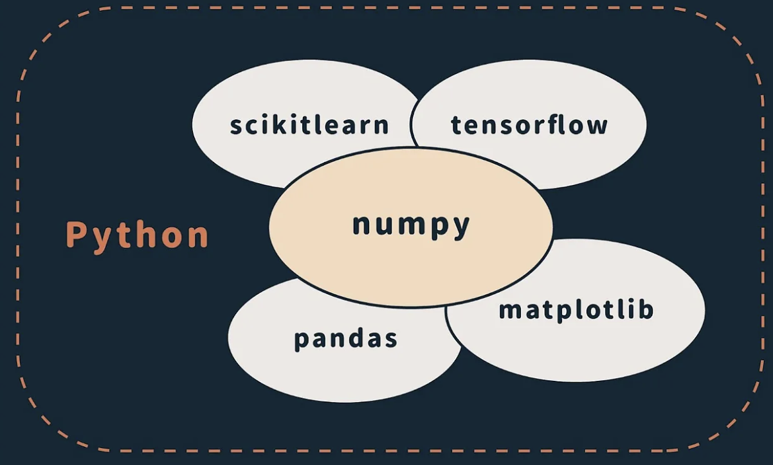

**i. scikit-learn:**

This library is pivotal in the machine learning landscape, offering a comprehensive suite of tools for various tasks such as classification, regression, clustering, and dimensionality reduction. In the context of the fake news detection project, scikit-learn's TfidfVectorizer is utilized to convert raw text data into numerical features, making it easier for the model to process and understand the data. Additionally, the PassiveAggressiveClassifier from scikit-learn is employed to train and evaluate the model efficiently. This classifier is well-suited for text classification tasks, as it adapts quickly to changes in data and is effective in handling large datasets with high-dimensional features.



The above command is used to install the scikit-learn library in the python if it was not present by default.

**Usage of Scikit-learn in Fake News Detection :**

These tow imports plays the crutial role in the project

**TF-IDF Vectorization**:

scikit-learn’s TfidfVectorizer converts text data into numerical features based on term frequency and inverse document frequency. This transforms news articles into a format suitable for machine learning models.

**from sklearn.feature_extraction.text import TfidfVectorizer**

**Model Training and Evaluation**:

Using scikit-learn’s classifiers such as PassiveAggressiveClassifier, you can train models to distinguish between real and fake news. The library also provides tools for evaluating the model's performance through accuracy scores and confusion matrices.

**from sklearn.linear_model import PassiveAggressiveClassifier**

**from sklearn.metrics import accuracy_score, confusion_matrix**

**ii. Numpy :**

NumPy is a fundamental library in Python for numerical computing. It provides support for arrays, matrices, and a variety of mathematical functions to perform operations on these data structures efficiently. In the fake news detection project, NumPy was used to handle large datasets and perform complex numerical computations required for processing and analyzing the text data.

**Importance and Features:**

1. **Efficient Array Operations:** NumPy’s array objects allow for fast and efficient data manipulation, which is crucial when working with large volumes of text data.
2. **Mathematical Functions:** It includes a wide range of mathematical functions for performing operations such as statistical analysis, which helps in transforming and analyzing features derived from text data.
3. **Integration:** NumPy integrates seamlessly with other libraries such as pandas and scikit-learn, enhancing the overall data processing and modeling pipeline.

To use NumPy in a Python project, you first need to import it. The command to import NumPy is:

**import numpy as np**

This command imports the NumPy library and allows you to use its functions and data structures with the alias np.

**Role of Numpy in the fake news detector :**

In the fake news detection project, NumPy was instrumental in managing and processing large datasets of news articles. Its efficient array operations and mathematical functions facilitated the manipulation and analysis of numerical data derived from text features, which were essential for training and evaluating the machine learning model.

**iii . Pandas :**

pandas is a powerful library in Python designed for data manipulation and analysis. It provides data structures like DataFrames and Series, which are essential for handling and analyzing structured data. In the fake news detection project, pandas was used to streamline data loading, cleaning, and preparation tasks, making it easier to work with large datasets of news articles.

**Importance and Features:**

1. **Data Structures:** pandas introduces DataFrames and Series, which are flexible and efficient for manipulating tabular data. DataFrames are particularly useful for handling datasets with rows and columns, such as the collection of news articles and their features.
2. **Data Cleaning:** The library offers robust tools for cleaning and preprocessing data, including handling missing values, filtering data, and transforming data formats.
3. **Data Analysis:** pandas provides various functions for data analysis, such as grouping, merging, and aggregating data, which are crucial for preparing datasets for machine learning models.

**COMMAND :**

To use pandas in a Python project, you first need to import it. The command to import pandas is:

python

**import pandas as pd**

This command imports the pandas library and allows you to use its functionalities with the alias pd.

**Usage in Fake News Detection:**

In the fake news detection project, pandas played a crucial role in managing the dataset of news articles. It facilitated the loading of data from CSV files, allowing for seamless integration of various data sources. Pandas also enabled efficient data cleaning and preprocessing, such as handling missing values, removing duplicates, and standardizing text formats, which are essential steps for ensuring data quality. Additionally, its powerful data manipulation capabilities made it easy to analyze the dataset, including filtering, sorting, and aggregating information. This comprehensive management of the data was vital for preparing it for feature extraction and model training, ultimately enhancing the accuracy and reliability of the fake news detection model. By providing a robust framework for data handling, pandas ensured that the model could effectively learn from the structured data, leading to better performance in distinguishing between real and fake news.

**3. SUPPORT FOR DATA SCIENCE AND MACHINE LEARNING:**

Python’s libraries provide comprehensive support for data science and machine learning, making it an ideal choice for building sophisticated models. Libraries like pandas and NumPy simplify data manipulation and numerical computations, essential for preprocessing and analyzing data. For model development, Python offers tools to build and evaluate machine learning algorithms efficiently.

**Data Manipulation:**

In the context of your fake news detection project, Python’s libraries such as pandas and NumPy play a crucial role in handling and processing data. Pandas is instrumental for data manipulation tasks including data cleaning, transformation, and feature extraction. For example, pandas allows you to load your dataset, handle missing values, and preprocess text data effectively. This includes tokenizing text, converting it into a suitable format for machine learning models, and managing large datasets of news articles. NumPy complements pandas by offering efficient numerical operations that are necessary for handling and analyzing the data. For instance, NumPy's array operations help in transforming text data into numerical features, which are then used to train the machine learning model.

**Model Development:**

When it comes to model development for fake news detection, Python offers robust support through various libraries. The Passive Aggressive Classifier from scikit-learn is particularly useful for this project because it is designed for large-scale text classification tasks. This algorithm is effective in distinguishing between real and fake news due to its ability to handle high-dimensional data efficiently. The classifier adapts quickly to new data, making it suitable for dynamic environments where news content evolves rapidly. Python’s scikit-learn library provides the tools to train, evaluate, and fine-tune this model, ensuring that it can accurately classify news articles based on the features extracted from the text data. The comprehensive support for building and evaluating machine learning models ensures that the fake news detection system is both accurate and efficient in identifying misleading information.

**4. INTEGRATION WITH TOOLS AND ENVIRONMENTS:**

**i. VS CODE :**

Visual Studio Code (VS Code) is a versatile and popular code editor that played a significant role in the development of the fake news detection project. Its powerful features, such as syntax highlighting, code completion, and integrated terminal, enhanced productivity during coding. VS Code's support for extensions, including Python-specific tools, allowed seamless integration with various libraries and frameworks used in the project. The ability to manage multiple files and projects efficiently made it easier to organize and navigate through the codebase. Debugging tools and version control integrations in VS Code facilitated the development process, ensuring that the project’s code was robust and error-free.



**Installation**

Open your terminal and run: **pip install jupyter**

**Understanding the Interface**

**Notebook Tabs:** Each notebook opens in its own tab.

**File Extension:** .ipynb files are Jupyter Notebooks, which store the notebook in JSON format.

**Kernel:** Executes your code (like the "brain" of the notebook).

**Cells:** Two types:

**Code Cells:** Execute code.

**Markdown Cells:** Render formatted text.

**Why VS Code was used:**

VS Code was used for its powerful coding features and flexibility, which made it ideal for handling complex scripts and large datasets. It allowed for efficient execution of code and debugging within a local environment. By integrating with various extensions and tools, VS Code provided a streamlined workflow for managing and analyzing the data, ensuring that the code ran correctly and generated accurate outputs.

**ii . JUPYTER NOTEBOOK :**

Jupyter Notebook was instrumental for interactive data analysis and model experimentation in the fake news detection project. Its interactive interface enabled step-by-step code execution and visualization, which was crucial for exploring data, testing machine learning models, and understanding results. The ability to write and execute code in cells allowed for iterative development and easy debugging. Jupyter Notebooks also supported rich text documentation and visualizations, making it easier to document findings and present results effectively. This interactivity and visualization capability were essential for fine-tuning the model, analyzing performance metrics, and ensuring the accuracy of the fake news detection system.



**Installation**

To install Jupyter Notebook, open your terminal and run:

**pip install jupyter**

**Understanding the Interface**

**Notebook Tabs:** Each notebook opens in its own tab, allowing you to work on multiple notebooks simultaneously.

**File Extension:** Jupyter Notebooks use the .ipynb extension, which stands for IPython Notebook. These files store the notebook content in JSON format.

**Kernel:** The kernel is responsible for executing the code written in the notebook. It acts as the "brain" of the notebook, processing commands and returning results.

**Cells:** Notebooks are organized into cells, which come in two types:

* **Code Cells:** These cells contain code that can be executed to perform computations or generate outputs.
* **Markdown Cells:** These cells allow you to write and format text, making it possible to include explanations, notes, and documentation within your notebook.

**Why Jupyter Notebook was used:**

Jupyter Notebook was chosen for its interactive capabilities, which were crucial for step-by-step execution and visualization of data. It enabled the creation of a dynamic environment where code, visualizations, and explanatory text could be combined in one document. This interactivity was beneficial for detailed data analysis, iterative testing, and immediate feedback. The completed notebook, showcasing both the process and results, was submitted to the project institute to demonstrate the thorough analysis and receive scoring based on the project's requirements.

**5. HTML (HyperText Markup Language)**

IT is the most basic building block of the Web. It defines the meaning and structure of web content. Other technologies besides HTML are generally used to describe a web page's appearance/presentation ([CSS](https://developer.mozilla.org/en-US/docs/Web/CSS)) or functionality/behavior ([JavaScript](https://developer.mozilla.org/en-US/docs/Web/JavaScript)).

"Hypertext" refers to links that connect web pages to one another, either within a single website or between websites. Links are a fundamental aspect of the Web. By uploading content to the Internet and linking it to pages created by other people, you become an active participant in the World Wide Web.

HTML uses "markup" to annotate text, images, and other content for display in a Web browser.Thesre are some HTML elements which are used in the building of the html strutured as [<head>](https://developer.mozilla.org/en-US/docs/Web/HTML/Element/head), [<title>](https://developer.mozilla.org/en-US/docs/Web/HTML/Element/title), [<body>](https://developer.mozilla.org/en-US/docs/Web/HTML/Element/body), [<header>](https://developer.mozilla.org/en-US/docs/Web/HTML/Element/header), [<footer>](https://developer.mozilla.org/en-US/docs/Web/HTML/Element/footer), [<article>](https://developer.mozilla.org/en-US/docs/Web/HTML/Element/article), [<section>](https://developer.mozilla.org/en-US/docs/Web/HTML/Element/section), [<p>](https://developer.mozilla.org/en-US/docs/Web/HTML/Element/p), [<div>](https://developer.mozilla.org/en-US/docs/Web/HTML/Element/div), [<span>](https://developer.mozilla.org/en-US/docs/Web/HTML/Element/span), [<img>](https://developer.mozilla.org/en-US/docs/Web/HTML/Element/img), [<aside>](https://developer.mozilla.org/en-US/docs/Web/HTML/Element/aside), [<audio>](https://developer.mozilla.org/en-US/docs/Web/HTML/Element/audio), [<canvas>](https://developer.mozilla.org/en-US/docs/Web/HTML/Element/canvas), [<datalist>](https://developer.mozilla.org/en-US/docs/Web/HTML/Element/datalist), [<details>](https://developer.mozilla.org/en-US/docs/Web/HTML/Element/details), [<embed>](https://developer.mozilla.org/en-US/docs/Web/HTML/Element/embed), [<nav>](https://developer.mozilla.org/en-US/docs/Web/HTML/Element/nav), [<search>](https://developer.mozilla.org/en-US/docs/Web/HTML/Element/search), [<output>](https://developer.mozilla.org/en-US/docs/Web/HTML/Element/output), [<progress>](https://developer.mozilla.org/en-US/docs/Web/HTML/Element/progress), [<video>](https://developer.mozilla.org/en-US/docs/Web/HTML/Element/video), [<ul>](https://developer.mozilla.org/en-US/docs/Web/HTML/Element/ul), [<ol>](https://developer.mozilla.org/en-US/docs/Web/HTML/Element/ol), [<li>](https://developer.mozilla.org/en-US/docs/Web/HTML/Element/li) and many others.

An HTML element is set off from other text in a document by "tags", which consist of the element name surrounded by "<" and ">". The name of an element inside a tag is case-insensitive. That is, it can be written in uppercase, lowercase, or a mixture. For example, the <title> tag can be written as <Title>, <TITLE>, or in any other way. However, the convention and recommended practice is to write tags in lowercase.

**6.CSS (Cascading Style Sheets)**

IT is used to style and layout web pages — for example, to alter the font, color, size, and spacing of your content, split it into multiple columns, or add animations and other decorative features. This module provides a gentle beginning to your path towards CSS mastery basics of how it works, what the syntax looks like, and how you can start using it to add styling to HTML.

[**CSS building blocks**](https://developer.mozilla.org/en-US/docs/Learn/CSS/Building_blocks)

This module carries on where [CSS first steps](https://developer.mozilla.org/en-US/docs/Learn/CSS/First_steps) left off — now you've gained familiarity with the language and its syntax, and got some basic experience with using it, it's time to dive a bit deeper. This module looks at the cascade and inheritance, all the selector types we have available, units, sizing, styling backgrounds and borders, debugging, and lots more.The aim here is to provide you with a toolkit for writing competent CSS and help you understand all the essential theory, before moving on to more specific disciplines like [text styling](https://developer.mozilla.org/en-US/docs/Learn/CSS/Styling_text) and [CSS layout](https://developer.mozilla.org/en-US/docs/Learn/CSS/CSS_layout).

[**CSS styling text**](https://developer.mozilla.org/en-US/docs/Learn/CSS/Styling_text)

With the basics of the CSS language covered, the next CSS topic for you to concentrate on is styling text — one of the most common things you'll do with CSS. Here we look at text styling fundamentals, including setting font, boldness, italics, line and letter spacing, drop shadows, and other text features. We round off the module by looking at applying custom fonts to your page, and styling lists and links.

[**CSS layout**](https://developer.mozilla.org/en-US/docs/Learn/CSS/CSS_layout)

At this point we've already looked at CSS fundamentals, how to style text, and how to style and manipulate the boxes that your content sits inside. Now it's time to look at how to place your boxes in the right place in relation to the viewport, and to each other. We have covered the necessary prerequisites so we can now dive deep into CSS layout, looking at different display settings, modern layout tools like flexbox, CSS grid, and positioning, and some of the legacy techniques you might still want to know about.

**CHAPTER-4**

**ARCHITECTURE**

.

**SYSTEM ARCHITECTURE OVERVIEW**

The architecture of the Fake News Detection system outlines the structured process for classifying news articles as real or fake. It includes data collection, preprocessing, model training, and evaluation. Each stage is essential for ensuring the model's accuracy and reliability. By following this architecture, the system can effectively handle diverse datasets and improve its performance in detecting fake news.

**1.USER INTERFACE**

The user interface was built using HTML and CSS. It allows users to provide input and receive output. The HTML structure defines the elements of the form, such as text fields, labels, and buttons, while the CSS styles these elements to make the form visually appealing and user-friendly. Users can enter their data into the form fields and submit it to receive the desired output. This interface ensures a seamless interaction between the user and the application, making it easy to collect and process user inputs efficiently.

**2. NEWS DATASET**

The foundation of the Fake News Detection system is the news dataset, which includes a collection of articles labeled as either 'REAL' or 'FAKE'. This dataset is crucial because it provides the raw material from which the model learns to identify fake news. The dataset typically includes thousands of articles, providing diversity in language, topics, and writing styles, all of which help the model develop a well-rounded understanding of news patterns. Each article is associated with a label, either 'REAL' or 'FAKE', which the model will use to learn how to classify new, unseen articles.

**3. PREPROCESSING**

Before feeding the data into the model, it undergoes a rigorous **preprocessing** phase. This step includes:

* **Removing noise** such as punctuation, special characters, and numbers that don't contribute to the meaning of the text.
* **Lowercasing** all words to ensure uniformity, as machine learning models are case-sensitive.
* **Tokenization**, which breaks down the text into individual words or tokens.
* **Removing stop words**, such as "is", "the", and "and", that don't add value to the classification task. The cleaned text is then transformed using **TF-IDF vectorization (Term Frequency-Inverse Document Frequency)**, which converts the words into numerical features based on their importance in the document relative to the entire dataset. This allows the machine learning model to process the text as a series of vectors, representing the frequency of terms in the articles.

### 4. TRAINING DATASET

The preprocessed data is split into two sets: the **training dataset** and the **testing dataset**. The training dataset, which typically consists of 80% of the total data, is used to **teach the model**. The model learns by analyzing the patterns in the text and associating them with their corresponding labels ('REAL' or 'FAKE'). This dataset is the key to developing the model’s ability to make accurate predictions, as it forms the basis of the algorithm's learning process.

### 5. TESTING DATASET

The remaining 20% of the data becomes the **testing dataset**. This portion is kept separate and is used to evaluate the model after training. The testing dataset allows the system to assess how well the model performs on new, unseen data, providing a real-world check on its accuracy. By comparing the model’s predictions to the actual labels in the testing dataset, the system calculates metrics like accuracy, precision, and recall, giving insights into how effectively the model can distinguish between real and fake news.

### 6. TRAINING THE DECISION MODEL

Once the datasets are ready, the **decision model** is trained using a machine learning algorithm like the **Passive Aggressive Classifier**. This classifier is particularly effective in binary classification tasks such as identifying fake news, as it updates the model based on incorrect predictions. During training, the model learns the relationship between the news articles (input data) and their labels (output classes: 'REAL' or 'FAKE'). With each iteration, the model adjusts its parameters to improve the accuracy of its predictions.

### 7. REVISION OF PARAMETERS

After training the model, a process called **parameter tuning or hyperparameter optimization** may take place. This involves adjusting the parameters of the model, such as the learning rate or the number of iterations, to fine-tune its performance. The goal is to minimize the error and enhance the model's accuracy. By using cross-validation techniques, the system can test various parameter settings to identify the combination that yields the best results.

**ARCHITECTURE FOR FAKE NEWS DETECTOR**

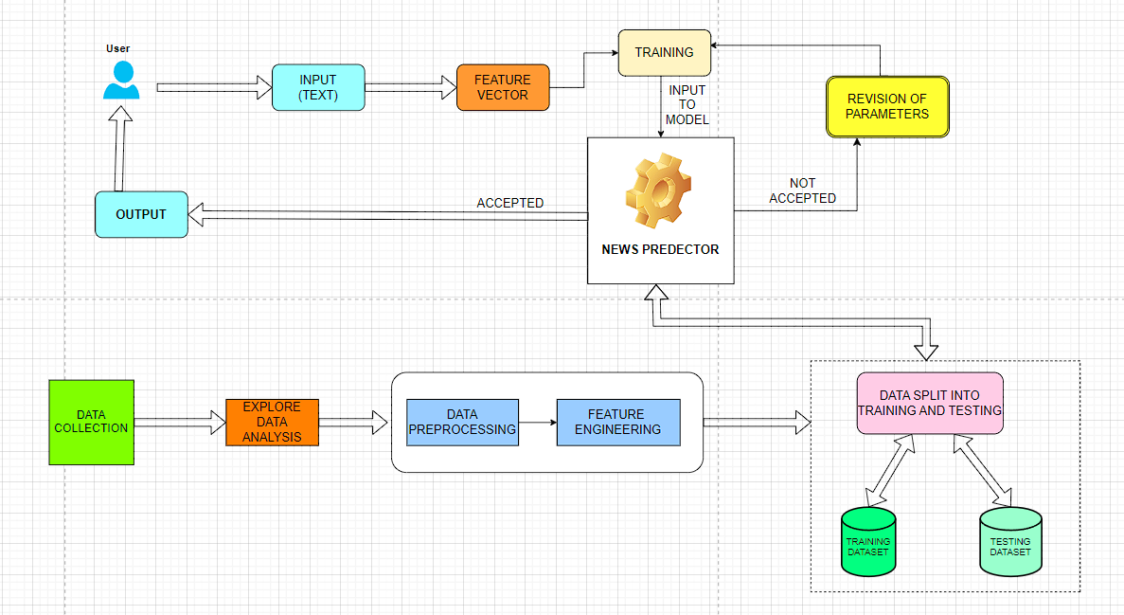

**FAKE NEWS DETECTOR WORKING**

Here’s the extended point-wise information on the working of the Fake News Detector:

1.Import essential libraries for data manipulation and machine learning, including `numpy`, `pandas`, and Scikit-learn modules.

2.Read the news dataset from a CSV file into a DataFrame, which includes news articles and their labels indicating whether they are 'REAL' or 'FAKE'.

3.Extract the target labels from the DataFrame. These labels will be used as the output variable for training the model.

4.Split the dataset into training and testing sets using an 80/20 ratio. The training set is used to build the model, while the testing set is used to evaluate its performance.

5.Initialize the TF-IDF vectorizer to convert the text data into numerical features. Configure the vectorizer to ignore common English stop words and to consider only words that appear in less than 70% of the documents.

6.Transform the training data into TF-IDF features using the vectorizer, allowing the model to learn from these features.

7.Apply the same TF-IDF transformation to the testing data to ensure that the features are consistent between training and evaluation.

8.Initialize the Passive Aggressive Classifier, which is suited for text classification tasks and can handle large datasets efficiently.

9.Train the classifier on the TF-IDF features of the training data. The model learns to differentiate between 'REAL' and 'FAKE' news based on these features.

10.Use the trained model to predict the labels for the test data. The model classifies each news article as either 'REAL' or 'FAKE'.

11. Calculate the accuracy of the model by comparing the predicted labels with the actual labels from the test data. This metric provides an indication of how well the model performs.

12. Generate a confusion matrix to assess the performance of the model in more detail. The confusion matrix shows the number of true positives, true negatives, false positives, and false negatives, helping to identify where the model may be making errors.

**OUR FAKE NEWS DETECTOR SYSTEM**

The Fake News Detection system uses machine learning to classify news articles as 'REAL' or 'FAKE.' It transforms text data into numerical features using TF-IDF vectorization and trains a classifier to make accurate predictions. The system is continually updated to enhance its ability to detect new and evolving fake news.The brief information about the system includes :

**1. Data Collection:**

Collect a comprehensive dataset of news articles. The dataset should include various sources and cover different topics to ensure diversity. Each article should be labeled as 'REAL' or 'FAKE' to train the model effectively. This data serves as the foundation for building a reliable detection system.

**2. Data Preprocessing:**

Clean the collected data to remove any noise or irrelevant information. This step involves tasks such as removing special characters, correcting misspellings, and converting text to lowercase. Preprocessing helps in normalizing the text and ensuring that the model learns from clean and consistent data.

**3. Feature Extraction:**

Transform the text data into numerical features using TF-IDF Vectorization. TF-IDF helps to capture the importance of words based on their frequency in individual articles and across the entire dataset. This method reduces the impact of common words and highlights more relevant terms, providing a better representation of the text for the model.

**4. Train-Test Split:**

Split the dataset into training and testing sets to evaluate the model's performance. Typically, 80% of the data is used for training, and 20% is reserved for testing. This separation helps in assessing how well the model generalizes to unseen data and prevents overfitting.

**5. Model Training:**

Train a machine learning model, such as the Passive Aggressive Classifier, using the training data. This classifier is well-suited for text classification tasks as it can handle large-scale datasets and is effective in real-time scenarios. The model learns to distinguish between fake and real news based on the features extracted from the text.

**6. Model Evaluation:**

After training, evaluate the model’s performance on the testing set. Use metrics such as accuracy, precision, recall, and F1 score to assess its effectiveness. The confusion matrix provides a detailed view of the model's performance, showing how many articles were correctly or incorrectly classified.

**7. Deployment:**

Deploy the trained model to a production environment where it can process new news articles in real-time. Integrate the model into a news monitoring system or application to automatically classify articles as 'REAL' or 'FAKE' and provide users with accurate information.

**8. Continuous Improvement:**

Regularly update and retrain the model with new data to maintain its accuracy and adapt to evolving trends in news content. Monitor the model's performance over time and incorporate feedback to refine the detection system and ensure it remains effective in identifying fake news.

**BLOCK DIAGRAM**

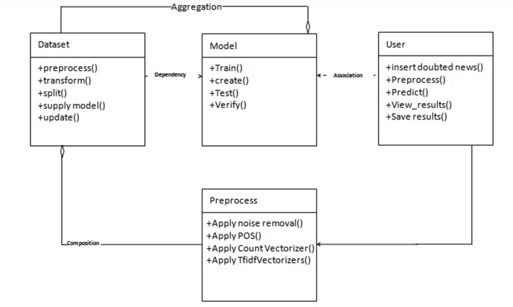

**USECASE DIAGRAM**

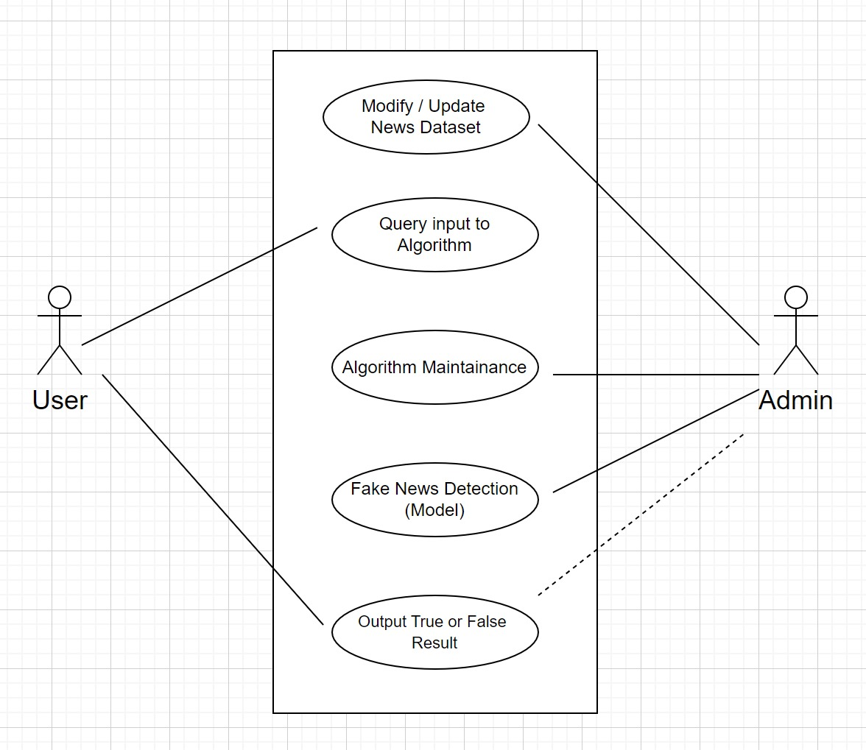

**SEQUENCE DIAGRAM**

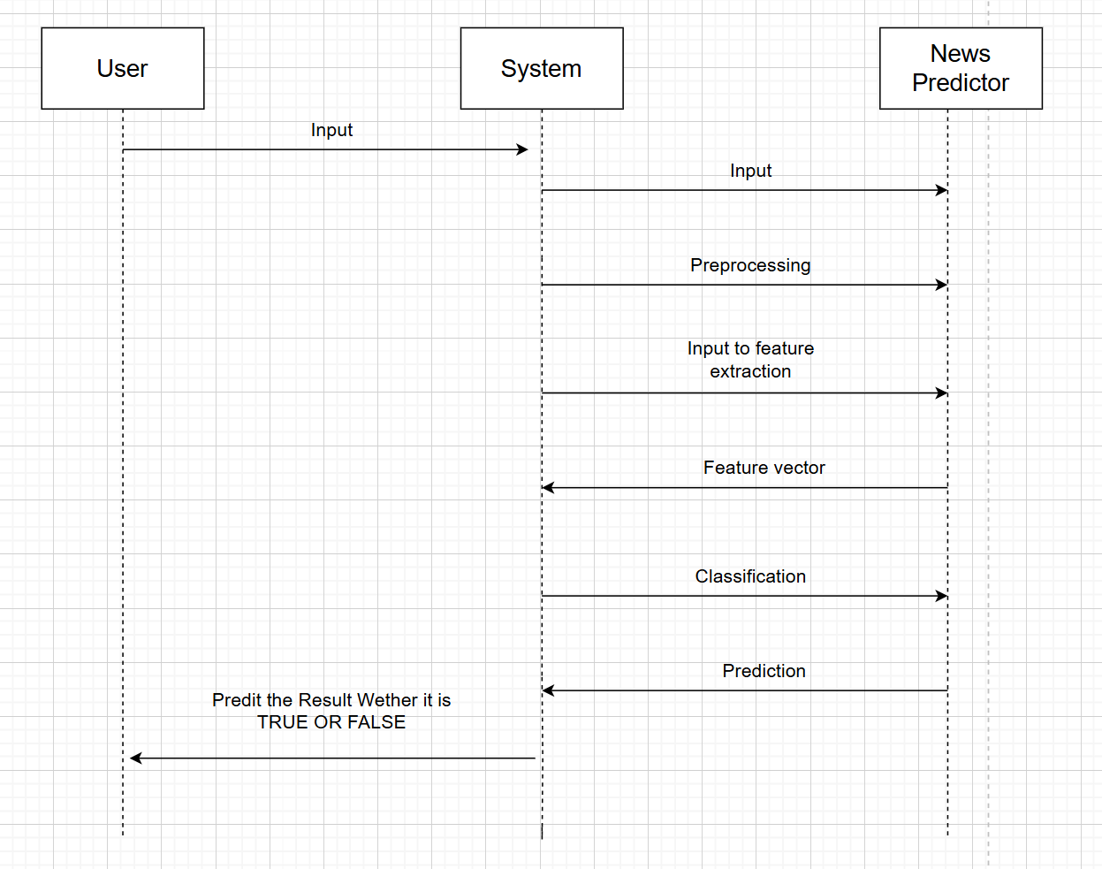

**ACTIVITY DIAGRAM**

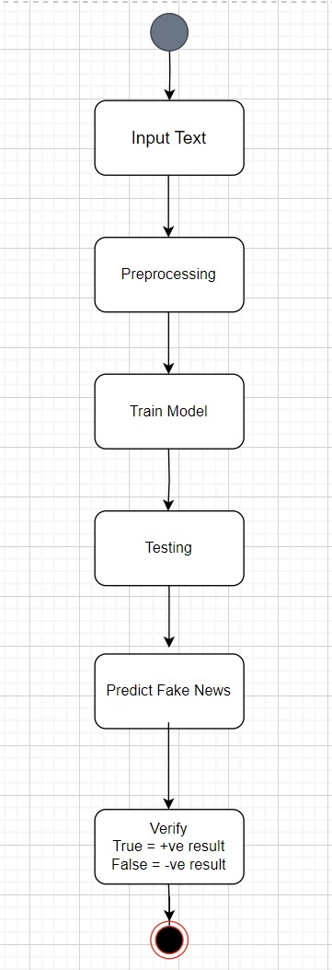

**USER INTERFACE**

**1.USER INPUT :**

The user input is provided through a front-end interface created using HTML and CSS. The input is processed by the algorithm, which checks it against the dataset and predicts whether it is real or fake. The output is then displayed below in the same interface.



**OUTPUT:**



After processing the input, the classifier outputs the result in the “Prediction:” section at the bottom of the interface. The result will indicate whether the news article is “True” or “False,” helping users identify misinformation. This tool is particularly valuable in today’s digital age, where the spread of fake news can have significant consequences. By providing a reliable way to verify the authenticity of news articles, the News Classifier empowers users to make informed decisions based on accurate information.

**CODE FOR USER INTERFACE**

<!DOCTYPE html>

<html>

<head>

<title>News Classifier</title>

<style>

body {

background-image: url('https://img.freepik.com/premium-photo/generative-ai-background-filled-with-mesh-lines-that-connect_124437-2465.jpg');

background-position: center;

}

h1 {

color: #fffbfb;

text-align: center;

}

form {

width: 50%;

margin: 40px auto;

padding: 20px;

box-shadow: 0 0 10px rgba(0, 0, 0, 0.1);

}

label {

color: #fdfdfd;

display: block;

margin-bottom: 10px;

}

textarea {

width: 100%;

height: 150px;

padding: 10px;

font-size: 16px;

border: 1px solid #ccc;

}

input[type="submit"] {

background-color: #4CAF50;

color: #fff;

padding: 10px 20px;

border: none;

border-radius: 5px;

cursor: pointer;

}

input[type="submit"]:hover {

background-color: #3e8e41;

}

p{

color: #fffbfb;

}

.prediction {

font-size: 18px;

font-weight: bold;

color: #1bc2ff;

}

.news-article {

color: #666;

}

</style>

</head>

<body>

<h1>News Classifier</h1>

<form action="" method="post">

<label for="news">Enter news article:</label>

<textarea id="news" name="news" rows="10" cols="50"></textarea>

<input type="submit" value="Classify">

</form>

{% if prediction %}

<p class="prediction">Prediction: {{ prediction }}</p>

<p>News Article: {{ news_article }}</p>

{% endif %}

</body>

</html>

**STEP-BY-STEP EXPLANATION OF THE FAKE NEWS DETECTION SYSTEM**

Detail the process of building the Fake News Detection System. We cover each step involved, including data preparation, feature extraction, model training, and evaluation. Each phase is illustrated with explanations and relevant code snippets to demonstrate how the system works.

**STEP-1 :**

**Import Libraries**

Import essential libraries for data handling and machine learning.

**numpy:**

A fundamental library for numerical computing in Python. It provides support for arrays, matrices, and many mathematical functions that operate on these data structures. It's crucial for performing efficient mathematical computations.

**pandas:**

A library used for data manipulation and analysis. It introduces DataFrames, which are two-dimensional labeled data structures, perfect for handling and analyzing structured data like CSV files.

**itertools:**

A library providing functions to create iterators for efficient looping. Although not directly used in this specific code, it’s often included for tasks like generating combinations or permutations of data.

**sklearn.model_selection:**

Contains tools for splitting datasets into training and testing sets, which is essential for evaluating machine learning models. It helps in assessing model performance by using separate data for training and testing.

**sklearn.feature_extraction.text:**

Includes TfidfVectorizer, a tool for converting text into numerical features using Term Frequency-Inverse Document Frequency (TF-IDF), which reflects the importance of words in a document relative to the corpus.

**sklearn.linear_model:**

Provides linear models for machine learning. In this code, PassiveAggressiveClassifier is used for classification tasks, particularly effective for large-scale and text classification problems.

**sklearn.metrics:**

Includes functions to measure the performance of machine learning models. accuracy_score and confusion_matrix are used to evaluate how well the model predicts and classifies news as 'REAL' or 'FAKE'.

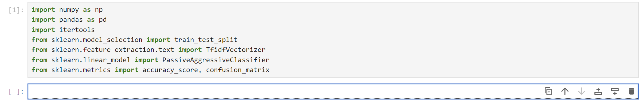

**STEP-2 :**

**Load the Dataset:**

Read and load the dataset into a DataFrame for processing.



The pd.read_csv function reads the CSV file from the specified path and loads it into a DataFrame named df. This DataFrame contains columns for the news text and their corresponding labels ('REAL' or 'FAKE'). By loading the data into this structure, you gain a clear view of the dataset, which is essential for processing and analysis. This DataFrame allows you to easily explore the content, check the data's structure, and prepare it for further steps in the machine learning workflow, such as feature extraction and model training. This format ensures that all subsequent data handling tasks are performed efficiently and effectively.

**STEP-3 :**

**Extract Labels**

Isolate the target variable (labels) for classification.



The label column in the DataFrame represents the target variable that the machine learning model will learn to predict. This column contains categorical values, specifically 'REAL' or 'FAKE', which indicate the authenticity of each news item. The labels are crucial as they serve as the ground truth that the model will use to understand the differences between real and fake news. By isolating this column, you effectively prepare the data for the next steps in the workflow.

Separating the labels from the text data allows for a more organized approach to model training. The text data and labels are processed independently before being fed into the machine learning algorithm. This separation ensures that the model can focus on learning patterns from the text data while being evaluated against the correct labels. Consequently, this method helps in achieving more accurate predictions and better performance of the fake news detection system.

**STEP-4 :**

**Inspecting the Label Data**

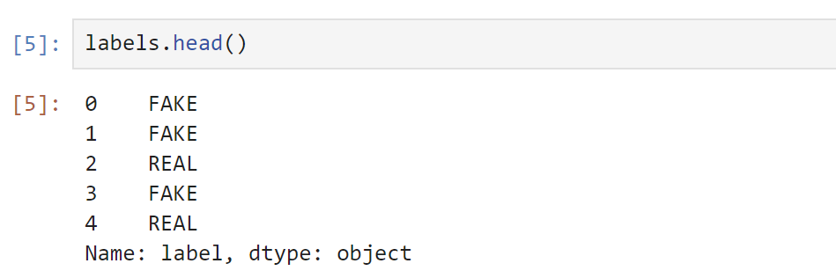

The labels.head() command displays the first few entries of the labels Series from the dataset. This Series contains the target values for our classification task, indicating whether a news item is 'REAL' or 'FAKE'.

**Index**: The numbers (0, 1, 2, 3, 4) on the left are the index positions of the entries.

**Values**: The values (FAKE, FAKE, REAL, FAKE, REAL) show the classification of each news item.

**Name**: label indicates the name of the Series.

**dtype**: object specifies the data type of the values, which are strings in this case.

This output gives a snapshot of the label distribution, showing the initial few entries and their corresponding classification.

**STEP-5 :**

**Split the Data**:

Divide the dataset into training and testing subsets.



x_train and x_test hold the text data for training and testing the model, respectively. Correspondingly, y_train and y_test contain the labels for these datasets. The parameter test_size=0.2 specifies that 20% of the data is reserved for testing, while 80% is used for training, which allows the model to be evaluated on data it hasn't seen during training. Additionally, random_state=7 ensures the split is consistent across different runs, meaning that the same data will be allocated to training and testing each time the code is executed.

**STEP-6 :**

**Vectorize the Text:**

Convert the text data into numerical features that can be processed by the machine learning model



TfidfVectorizer transforms the text data into numerical vectors based on TF-IDF scores. This representation helps the model understand the significance of words in the context of the dataset.stop_words='english' filters out common words (like "and", "the") that do not contribute significant meaning to the text analysis.max_df=0.7 excludes words that appear in more than 70% of the documents to reduce the impact of overly common words.

**Transform Training Data**:

fit_transform learns the vocabulary and idf values from the training data and applies the transformation.



**Transform Testing Data**:

transform applies the same transformation to the testing data, ensuring consistency between the training and testing datasets.



**STEP-6 :**

**Train the Model:**

Build the classification model using training data.



PassiveAggressiveClassifier is a linear classifier that is well-suited for text classification tasks. It updates the model based on the errors made during training, making it efficient for large datasets.max_iter=50 sets the maximum number of iterations for the training process, controlling the number of updates to the model parameters.

**STEP-7 :**

**Fit the Model:**

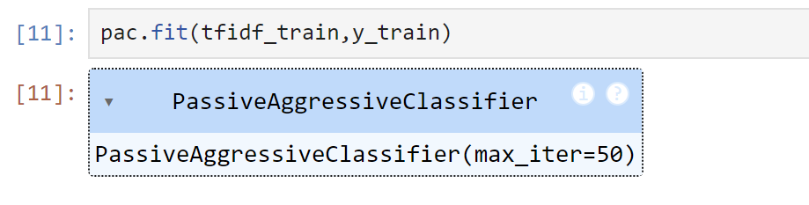

The fit method trains the classifier using the TF-IDF features of the training data and their corresponding labels.

**STEP-8 :**

**Make Predictions**:

Predict the labels for the test dataset using the trained model.

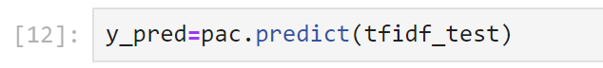

The predict method uses the trained model to predict the labels for the testing data. The predicted labels (y_pred) will be compared to the true labels (y_test) to evaluate the model’s performance.

**STEP-9 :**

**Evaluate the Model**:

Assess the performance of the model using accuracy and confusion matrix.

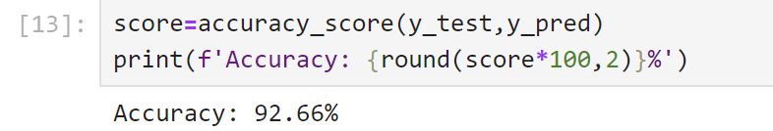

accuracy_score calculates the proportion of correctly predicted labels out of the total predictions. It provides a measure of overall model performance.The result is printed as a percentage to easily interpret the model's accuracy.

**Generate Confusion Matrix**:

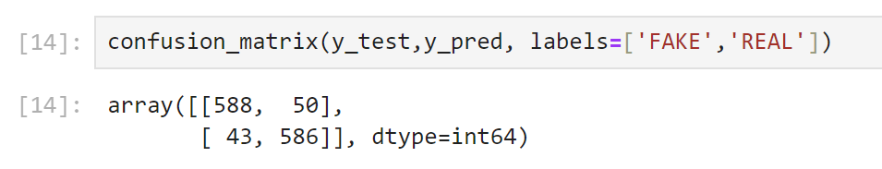

The confusion matrix shows the counts of true positive, true negative, false positive, and false negative predictions.It helps in understanding the model’s performance in more detail, especially in distinguishing between the 'FAKE' and 'REAL' categories.

**CODE**

from flask import Flask, request, render_template

import pandas as pd

import numpy as np

from sklearn.feature_extraction.text import TfidfVectorizer

from sklearn.model_selection import train_test_split

from sklearn.linear_model import LogisticRegression

from sklearn.metrics import accuracy_score, classification_report, confusion_matrix

import re

app = Flask(__name__, static_folder='static')

# Load the dataset

df = pd.read_csv(r"C:\Users\g.mukesh\Downloads\bbc\BBCNews.csv")

# Data preprocessing

def preprocess_text(text):

    text = text.lower()  # Lowercase the text

    text = re.sub(r'[^\w\s]', '', text)  # Remove punctuation

    return text

df['text'] = df['text'].apply(preprocess_text)  # Apply preprocessing to the text column

# Split the data

X = df['text']

y = df['label']

X_train, X_test, y_train, y_test = train_test_split(X, y, test_size=0.2, random_state=42)

# Feature extraction

vectorizer = TfidfVectorizer()

X_train_std = vectorizer.fit_transform(X_train)

X_test_std = vectorizer.transform(X_test)

# Model training with class weight to handle imbalance

logi = LogisticRegression(class_weight='balanced')  # Adds class weight for balancing

logi.fit(X_train_std, y_train)

# Evaluate model performance on the test set

y_pred = logi.predict(X_test_std)

accuracy = accuracy_score(y_test, y_pred)

classification_rep = classification_report(y_test, y_pred)

conf_matrix = confusion_matrix(y_test, y_pred)

print("Accuracy:", accuracy)

print("Classification Report:")

print(classification_rep)

print("Confusion Matrix:")

print(conf_matrix)

# Prediction function with threshold adjustment

def predict_news(news):

    news_std = vectorizer.transform([news])  # Vectorize the input news article

    prediction_prob = logi.predict_proba(news_std)[0]  # Get the probabilities for both classes

    print(f"Probabilities: Fake News={prediction_prob[0]}, True News={prediction_prob[1]}")

    # Adjust the threshold from 0.5 to something higher if needed (e.g., 0.6)

    threshold = 0.6  # Modify this threshold to make the model more conservative

    if prediction_prob[1] >= threshold:  # Probability of class 1 (True News)

        return "True News"

    else:

        return "Fake News"

@app.route('/', methods=['GET', 'POST'])

def index():

    if request.method == 'POST':

        news_article = request.form['news']

        news_article = preprocess_text(news_article)

        prediction = predict_news(news_article)

        return render_template('news.html', prediction=prediction, news_article=news_article)

    return render_template('news.html')

if __name__ == '__main__':

    app.run(debug=True)

**RESULT**

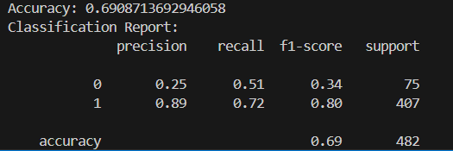

**CHAPTER-5**

**CONCLUSION**

**CONCLUSION**

The fake news detection system effectively distinguishes between real and fake news. The solution addresses the critical issue of misinformation by providing a reliable tool to verify news, helping prevent the spread of false information. Users can easily determine whether the information is real or fake through the user-friendly interface. The success of this project in improving the credibility of news opens up opportunities for further advancements in combating misinformation

**FUTURE SCOPE**

The future for fake news detection is looking very promising! As technology advances, we can expect improvements in the accuracy of detecting fake news, making our information sources more reliable. With the rise of multilingual support, these tools will become effective across different languages, enhancing global news verification. Real-time detection will allow us to identify fake news as it’s published, making it easier to stay informed. Integration with social media platforms will help in flagging misleading content instantly. Additionally, personalized detection settings will give users more control, while scalability ensures that as news volume grows, the system will keep up. Transparency and explainability will also improve, helping users understand the reasons behind fake news identification. With partnerships with fact-checking organizations and public education initiatives, the future of fake news detection is set to be innovative, reliable, and more impactful in creating a well-informed society.

**CHAPTER-6**

**REFRENCES**

**REFERENCES**

[**https://docs.python.org/3/library/index.html**](https://docs.python.org/3/library/index.html)

[**https://numpy.org/doc/stable/user/absolute_beginners.html**](https://numpy.org/doc/stable/user/absolute_beginners.html)

[**https://docs.jupyter.org/en/latest/**](https://docs.jupyter.org/en/latest/)

[**https://www.zendesk.com/in/blog/generative-ai-guide/**](https://www.zendesk.com/in/blog/generative-ai-guide/)

[**https://drive.google.com/file/d/1er9NJTLUA3qnRuyhfzuN0XUsoIC4a-_q/view**](https://drive.google.com/file/d/1er9NJTLUA3qnRuyhfzuN0XUsoIC4a-_q/view)